Project Doc

0 . Cover
Project name: Berlin Apartment AI Assistant
Team members: Nadir Bašić, Luka Radulovikj, Eric Germersdorf
Date / version: 2026‑04-27 – Draft v0.0.1 dev

1. Problem Statement & Vision
One‑sentence pitch – “Help Berliners find a good apartment quickly, affordably, and make informed decisions from a comprehensive overview.”

Why now? / Stakeholders – Pain points, target users, success criteria.

Most solutions focus on Germany, and on ‘quick’ apartment finding, ours focuses on interactivity and intelligence - providing the user with a comprehensive overview of apartment listings through conversations with a chatbot.

2 . Scope [Eric]
Must‑have (MVP): Describe an apartment to a chatbot, get back results visualized on a map and iterate with chatbot until happy.
Nice‑to‑have: Contextual information for apartments, including noise levels, greenery, public transport connectivity, closeness to schools, hospitals…
Stretch goals Chatbot provides information on over/underpricing of the apartment relative to similar ones, automated daily searches for users, automated applying to apartments.

Explicitly list what is out of scope to prevent scope creep.

- Other cities other than Berlin are out of scope.

3 . User Stories
“I’m moving to Berlin in a month from now, and I haven’t yet found an apartment! All of these different websites, forms and applications have gotten me so confused! I wish I could just ask ChatGPT to find me a flat…”

“I want to find an apartment and I’m picky. I want a nice area, good commute, 3 bedrooms, etc. I spend hours researching myself and comparing apartments day to day.”

“I’m tired of juggling multiple sites and endless listings. I want clear, honest summaries so I can quickly find and apply to apartments that actually match my needs.”

… add more

4 . System Overview
Still not fully determined, we will keep it agile and make decisions as we go. But the system will probably look something like below:
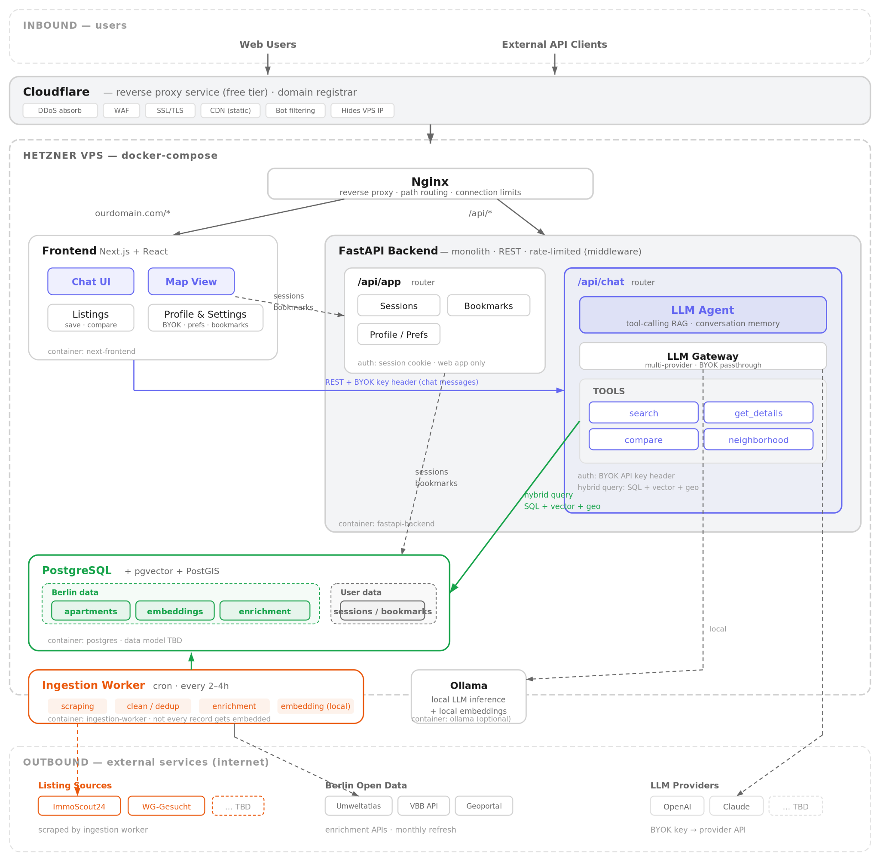
Decisions:
- VPS hosting (e.g Hetzner) is simplest, cheapest, and should be satisfactory on our scale
- Cloudflare's free tier provides DDoS protection, CDN, WAF, and SSL - we can also register our domain through their registrar for seamless integration
- The backend will be a monolith for simplicity, but the chatbot router will be exposed both to the web app and external api clients, e.g telegram bots. We can even plan for more integration, e.g exposing the search MCP API, by keeping things modular and planning on time
- For the MVP, we will implement minimal user management and persist sessions, bookmarks, and enable BYOK for LLM interactions
- On our scale, PostgreSQL can handle the semantic vector search, structured and geo data
- The data ingestion is implemented as a cron job, and will be designed to make minimal requests and comply with all ToS

Tech stack:
- Cloudflare, Nginx
- React, Next.js
- FastAPI, sqlalchemy, [LLM gateway, framework, agent framework, search framework TBD]
- PostgreSQL
- Docker, Docker Compose

6 . Project Plan & Timeline [@PM]
Week Milestone Owner Deliverable
1 Repo, Bob URL + README
2–3 PDF‑ingest pipeline Carla /api/upload working
4 First Q&A demo Team Live demo
5 UX polish, tests Alice Usability test results
6 Stretch goal pick — PR merge
7 Load test & deployment Team Prod URL
8 Final presentation Team Slide deck

7 . Roles & Responsibilities
Role Person Key Duties
Product / PM Eric Scope, timeline, domain expertise, data source expert
AI/Software Engineer Luka Scraper module, DB
AI/Software Engineer Nadir Chatbot and search development

Decision making process - we will keep it light and agile, and let most decisions be made autonomously. During meetings and PR reviews we can verify some decisions post-hoc. Important decisions will be made together via chat or in meetings.

8 . Risk Register
Risk Probability Impact Mitigation
ToS Violations Medium Medium Compliant service usage
Pricing Medium High Agentless search, caching
Large scope High Low Focus on delivering viable versions before including all features

9 . Evaluation & Demo Plan
- Success metrics – user acceptance testing, search results benchmarking.
- Demo script – live demo where we ask someone from the audience to describe an apartment they would like to live in, prompt and review results, showcase user profile bookmarks.
- Backup video in case Wi‑Fi fails.

